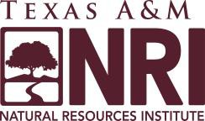
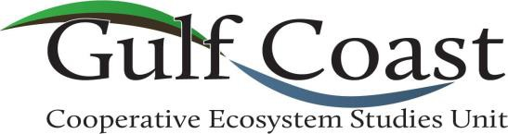

Annual Meeting

February 1, 2024

9:00 am – 11:00 am

Welcome – Debbie Danford, Director, Gulf Coast Cooperative Ecosystems Studies Unit

Texas A&M Natural Resources Institute (NRI) Director’s and Associate Director’s Remarks
Dr. Roel Lopez, Director-NRI
Dr. Jim Cathey, Associate Director-NRI

National CESU Office Update – Dr. Tom Fish, National Coordinator, CESU Network
FY 2024 National Meeting
Projects Database
Expert Database

Federal Partners’ Remarks
- Department of Defense - Elizabeth Galli-Noble, DoD Legacy Resource Management Program
- Defense POW/MIA Accounting Agency – Kenneth Humphrey, Integration and Development Manager for DPAA Partnerships and Innovation
- U.S. Fish and Wildlife Service - Megann Santana, Regional Military Lands Partnership Coordinator
- National Park Service - Dr. Giselle Mora-Bourgeois, GC-CESU Liaison and Research Coordinator
- US Army Corps of Engineers – Kathy Mitchell, Environmental Agreements PM, USACE Regional Planning & Environmental Center

GC-CESU Expert Database Demonstration – Ross Anderson, Associate Director, NRI

Research Presentation – Validation of Automated Monitoring Technology for Reintroduced Populations of the Federally Threatened Eastern Indigo Snake – Dr. Wade Ryberg, NRI

New Member Presentations
- Arkansas Game and Fish Commission
Brad Carner, Deputy Director
- American Bird Conservancy
Emily Williams, Vice President, Migratory Birds and Habitats
Anne Mini, Science Coordinator, Lower Mississippi Joint Venture

Partner Q&A

