Graduate Student Funding Available for Research in Rocky Mountain National Park!
Rocky Mountain National Park and Rocky Mountain Conservancy are currently accepting applications for the 2025 Bailey Research Fellowship. The Bailey Research Fellowship provides opportunities for highly qualified graduate students to conduct research in the park and communicate their work to the public.
The fellowship provides park housing, a living stipend, and support for research supplies and conference attendance. The goal of the fellowship is to support graduate student research that aids in park management and decision making.
For more information, visit: Bailey Research Fellowship
Applications accepted through February 16, 2025.

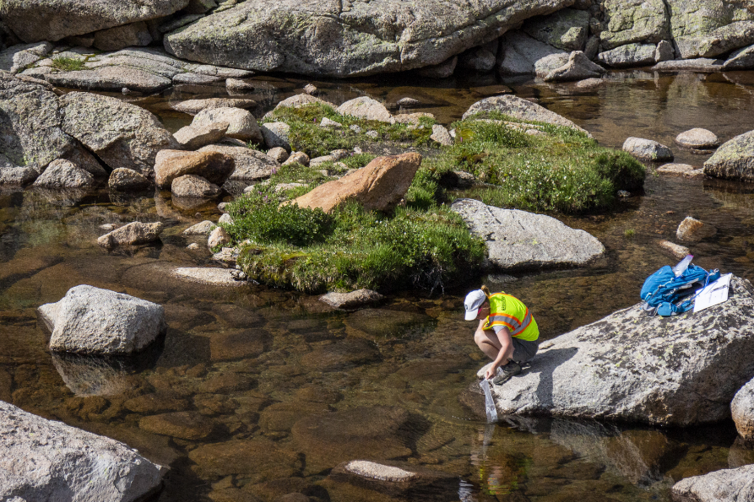
NPS Photo/L. Scott. A graduate student kneels to collect water samples in a lake.

